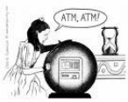
Welcome to
Team ATM
Dear Team ATM:
We are so excited that YOU are going to be on Team ATM this year and look forward to seeing you in September. We think that you will enjoy sixth grade, and we will have fun learning, laughing, and growing together. Our curriculum in the sixth grade is challenging and rewarding.
Most students really enjoy sixth grade. We have lots of former students that still come back to visit us. We pride ourselves on creating a learning environment where everyone feels safe, accepted, and driven to work to their highest potential. In the meantime, have a wonderful summer–run, play, visit the beach, and explore. Take some time out to keep up with your summer reading, too. Visit the Abbott or Boston Public Library. Libraries always have innovative summer programs. Then, bring your smile and your imagination and you'll be ready for sixth grade. We are looking forward to meeting you.
See you soon!
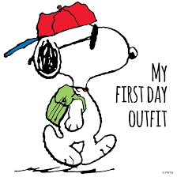
Mr. Angelopolus & Ms. Trainor-Madigan

Team ATM “Green” Supply List In order to go green, try to finish off some of last year’s supplies before getting new supplies. We all should try to think creatively to preserve our resources for a greener world & a greener wallet.
Supply List
Each Student will need:
〇 1 Pencil case or clear Ziplock™ bag with the student’s name to contain the following…
- 1 Dozen pencils (or more!)
- 1 Handheld pencil sharpener
- 3 multi-color highlighters (or more!)
- 1 Pen (or more!)
- 1 Box of washable markers
- 1 Box of 12 or more colored pencils
- 1 Pair of scissors
- 1 Two Inch Binder
- 1 Pack of 3 or more glue sticks
- 1 Pack of Post-its™
- 2 Rolls of Scotch™ tape (or more!)
- 1 Two pocket folders for Homework
- 1 Pair of headphones with a plug (low tech old school, not Bluetooth)
- A library card (can be Abbot, Boston, or any library!). Sign up for an Abbot card here https://marblehead.noblenet.org/eg/opac/register
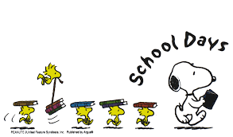
Team ATM would greatly appreciate donations of extras of the required items and anything from our wish list from below…

- Pencils
- 1 Box of tissues (or more!)
- 1 Roll paper towels (or more!)
- Thick/thin-all sizes all colors of Sharpies™
- White-out
- Blue Painter’s Tape or Washi Tape
- Cleaning wipes (i.e. Clorox or Lysol)
- Hand sanitizer
- Colorful copy paper
- Construction paper
- Thin and thick Expo™
- Expo™ marker wipes
- Two Heavy Duty Electric Pencil Sharpeners
- Bird Suet Cakes
- Postage Stamps
- Eraser Tops
- Electric or manual 3 Hole Punch

Allied Arts requests…
- 1 One-subject notebook & two pocket folder for World Language
- Two pocket folder for General Music

Thank you!

