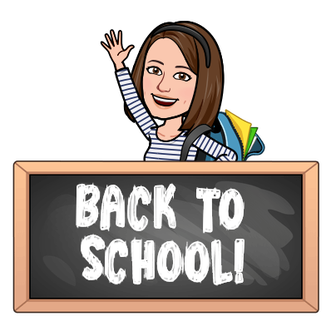
Summer 2023
Dear 4th Grader and Family,
Welcome to 4th grade and Village School! I hope you are having a wonderful summer filled with relaxation and new adventures. I’m so excited to be your teacher and I can’t wait to meet you!
This year we will be exploring the geography of the United States, sharing our thoughts about the books we are reading, writing stories and poems, and solving math problems. We will also be acting, drawing, calculating, experimenting and having lots of fun together. Like many of you, I am better at some of these things than I am at others, but together we will accomplish great things!
My favorite part of school is building a classroom community. This year we will enjoy learning about each other, learning from each other, and creating a strong classroom community where everyone feels safe and welcome.
Attached is a list of supplies you will need for the first day of school. Be sure to check out our classroom website too. I look forward to meeting you soon!

Sincerely,

Miss Welsh

Email: welsh.caitlin@marbleheadpublicschools.org

Class Website:
https://sites.google.com/marbleheadschools.org/welsh4/home

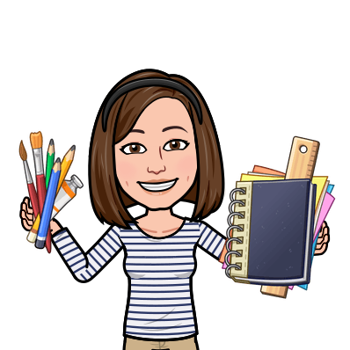
Supply List:

Personal Items:
- 1 one inch heavy duty view binder (Avery is a common brand)
*Nothing bigger than 1 inch, and no zippers please!*
- 1 plastic, 3 hole punched, 2-pocket folder for homework
- 1 Clipboard
- 1 folder for Music

Community Items: Everyone is asked to bring these items in with them. I will collect them for the entire class to use during the school year.
- 1 pack Expo dry erase markers (low odor)
- 1 pack of Ticonderoga #2 pencils (pre-sharpened would be great!)
- 1 pack of glue sticks
- 1 24 pack or 36 pack of Crayola colored pencils (no erasers or Twistables please)
- 1 pack of Crayola Supertips Markers (20 or 50 pack)
- 1 pack of disinfecting wipes (Seventh Generation would be great!)

Optional / Wish List Items:
- Ziploc baggies (sandwich size and/or gallon size)
- Additional art supplies (specifics on Amazon wishlist)
- Recess toys (specifics on Amazon wishlist)
- Indoor recess games (specifics on Amazon wishlist)
- Classroom library books (specifics on Amazon wishlist)

Thank you in advance for your support!

