WELCOME TO 4th!
​
​Dear Fourth Grader and Family,

Welcome to 4th grade and Village School! We hope that you are enjoying your summer break, and have had plenty of time to have fun and relax!
We are looking forward to seeing you on our first day of school. Our class has an exciting adventure ahead of us! This year in 4th grade we will be exploring the geography of the United States, sharing the books we are reading, writing poems and stories, and thinking mathematically. We will also be acting, drawing, calculating, singing, doing experiments, and having lots of fun together as we learn!
To help you get ready for school, we have attached a list of materials that you will need for the year. Most importantly, don’t forget to read a minimum of three books this summer. We look forward to hearing about what you’ve read!
We hope you enjoy the rest of the summer with your family and friends. We are looking forward to meeting you soon!

Sincerely,
Ms. Hood & Mr. Wales

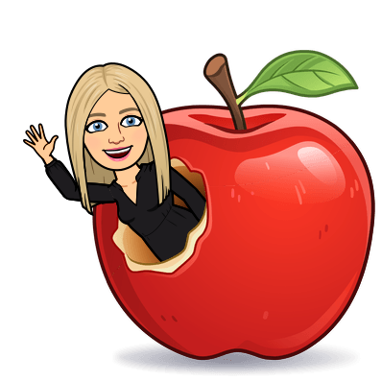
Emails:
hood.hannah@marbleheadschools.org
wales.herrick@marbleheadschools.org

Supply List:

Personal Items:
● 1 one-inch heavy duty view binder (Avery is a common brand)
*Nothing bigger than 1 inch, and no zippers please! *
● 1 plastic, 3 holes punched, 2-pocket folder for homework
● 1 folder for Music

Community Items: Everyone is asked to bring these items in with them. I will collect them for the entire class to use during the school year.
● 1 pack of Ticonderoga #2 pencils (pre-sharpened would be great!)
● 1 pack of glue sticks
● 1 pack of Crayola colored pencils (no erasers or Twistables please)
● 1 pack of Crayola markers (thick or thin)
● 1 pack of Post-Its
● 1 roll of paper towels
● 1 pack of Clorox wipes
● 1 box of tissues

Optional / Wish List Items: If you are able to donate an item from our classroom Amazon Wishlist, it would be beyond appreciated!
Link: https://www.amazon.com/hz/wishlist/ls/1SJN76K5Z1BSJ?ref_=wl_share

Thank you in advance for your support!

