BH-6
Mrs. Belli (ELA/SS) and Mr. Heller (Math/Sci)

Welcome to our team!
Each year brings new opportunities to learn and grow! We’re eager to start a new school year with you and confident you’ve reached milestones to applaud and some learning you’re hoping to progress in the upcoming year.
Parents, as your child’s teachers, we are committed to creating a classroom culture that prioritizes care, relationships, and community, regardless of how and where our students learn. However, we realize that before students can engage with challenging topics, they need to feel confident that they are part of a brave and reflective community where they are known, valued, and supported by their teachers and peers. Creating a classroom culture of thinking, embracing challenges, and learning through mistakes is at the core of our teaching philosophies. Gear up for a great year!
With this said, communication is essential; our team believes in creating lasting family-school connections. Our Parent Survey and Remind link are two areas that will support our learning and engagement with one another. Please take a quick moment to take the survey and sign-up for Remind Communications.
Lastly, it is vital that we lay the groundwork for student-centered spaces with meaningful activities and routines to launch in-depth learning topics. Twenty years from now, our students will not remember the worksheets and packets we assigned them—no matter how cute or fun they are. It is unlikely that such work will not have a long-term impact. Instead, the value systems we construct and communicate to students will hopefully shape their identities to see the world long after they leave us.

Academic Supply List
As we prepare for the start of the new school year, we’d like to provide you with a list of supplies to help get the year off to a great start. For your convenience, we have created an Amazon link for quick ordering. Some of the supplies on the list will be collected as team supplies during the first week of school. This is a critical step in setting the expectations for our team throughout the year. We will monitor our collections throughout the year and ask students to replenish them as needed.
Summer Reading Book: Suggested books are listed on Village Learning Commons Summer Reading List)
Please have your child bring the following items with them on the first day of school:
- Headphones with microphone
- BHG will be 1:1 with Chromebooks for 2023-2024 for ALL students to use during the school day. Chromebooks will be available for all students to use during the school day.
  - If your child would like to use their own Chromebook or iPad (with keyboard), they are welcome to bring a personal device to school. However, it remains optional for BHG students to bring their personal devices during the school day.
- 1 package of paper towels (to share)
Best wishes to all of you for a peaceful, joyous summer full of loved ones, sunshine, and good books.
Eager to learn,
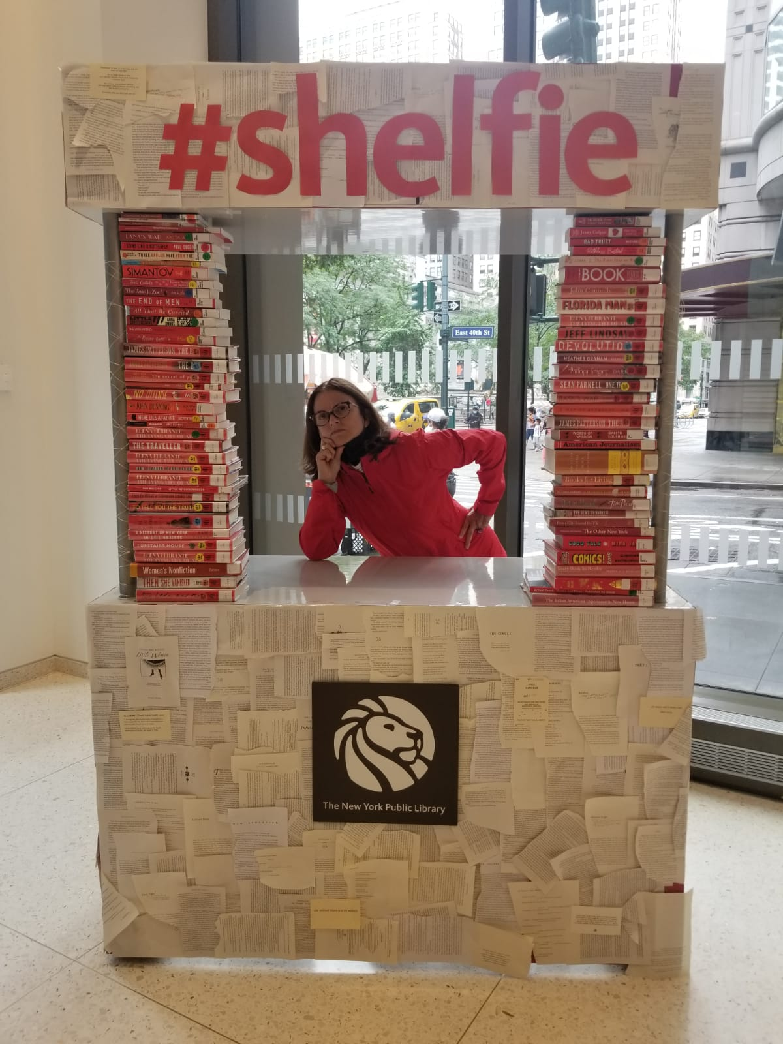  Natalie Belli | Jonathan Heller

