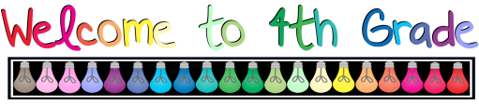Summer 2023
Dear Fourth Grader and Family,
Welcome to 4th grade and Village School! I hope that you are enjoying your summer and that you have had time to relax and have fun. I am very excited to spend this year with you!
Our class has an exciting adventure ahead of us! This year in 4th grade we will be exploring the geography of the United States, sharing the books we are reading, writing poems and stories, and thinking mathematically. We will also be acting, drawing, calculating, singing, doing experiments, and having lots of fun together as we learn!
I would like to share some of the goals I have for our class this year. I hope to build a strong classroom community and make connections between what we learn and our own lives. My hope is that each student in our class will grow as a reader, writer, scientist, and mathematician. What are your goals for fourth grade? What are some things you are looking forward to? I can’t wait to meet you and start this adventure together!
Sincerely,
Mrs. Sweet ☺
P.S. - Attached is a list of supplies needed for the year. I want to thank all the parents in advance for all of their support!
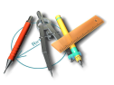
Supply List
Personal items:
1 inch Binder (this size is essential to fit into student bins)
1 pair of durable wired headphones
Community Items: Everyone is asked to bring these items. We will collect them for the entire class to use during the school year, so you don’t need to write your name on the supplies.
1 pack of pre-sharpened #2 Ticonderoga Pencils
(Ticonderoga is by far the best and most successful)
1 pack of 24 or 36 pack of Crayola Colored Pencils - no erasers or twistables please 1 pack of Post-It Notes
1 container of Clorox Wipes
$10 for Scholastic Storyworks Magazine Subscription
Wish List Items:
● paper towels
● small boxes of tissues
● clear packing tape
● Ultra Thin Sharpies (colorful & black)
● Recess Toys (please see Amazon Wishlist)
● Classroom Library Books (pleasee see Amazon Wishlist)
Appreciated Wish List Items on Amazon: Click Here for Wish List

