Dear Students and Families,

I hope you are enjoying your summer and are looking forward to an exciting year in a fun, friendly classroom! This is going to be a fantastic school year and I am busily planning and preparing for it.
This summer I’ve been enjoying working in my garden, going to the beach, and playing with my dog Bruin. I’ve also been reading some great books. I’ve especially enjoyed reading El Deafo, by Cece Bell- our required fourth grade summer reading book. Have you read it yet? I can’t wait to hear if you enjoyed it as much as I did!!!
Along with reading some good books, I hope you have had a chance to relax, unwind and enjoy the sunshine this summer. I can’t wait to meet all of you in a few weeks! I hope you are as excited as I am to spend an amazing year growing and learning together? To get ready for our year, I would like to share some of my hopes and dreams for our classroom community.
I hope that students and teachers in our class will get to know each other well and that we’ll build a strong learning community. I hope that we will make connections between what we learn and our own lives. Last but not least, I hope that all students in our class will feel included, will feel recognized for their effort and positive attitude, and will have fun learning !
What are your hopes and dreams for this school year? Take a couple of minutes this summer to reflect on previous school years and what your new hopes and dreams will be for fourth grade. What goals will you set for yourself this year? Let’s reach for the stars and try lots of new and fun things together!! I can’t wait to get started! To help you get off to a great start, I’ve included a supply list on the next page. Please let me know if there is anything I can assist you with. Thank you to all students and families in advance for your support!
See you soon!

Love,

Mrs. Sheridan

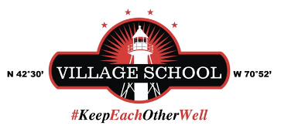
Sheridan Grade 4
Supply List

- Pencils (1-2 box Ticonderoga pre-sharpened)
- 1 small handheld pencil sharpener (with cover to trap shavings)
- Colored pencils
- Crayola markers- both thick and thin
- 1 yellow highlighter
- 1 pink highlighter
- Headphones to keep at school (not wireless)- I do have some in the classroom if needed
- 1 pack of 3X3 sticky notes
- 1 plastic (heavy duty) two pocket folder for homework
- scissors
- 3 glue sticks
- 2-3 thin expo markers (black or blue)
- 1 non spill water bottle- labeled with your child’s name on it 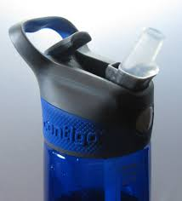
- Canvas pencil pouch with handle to hang on desk hook (see links below)
https://www.amazon.com/SPACEMATE-Heavy-Canvas-Pencil-Pouch/dp/B0BZY73QGL or

Amazon.com: WEMATE Large Pencil Case, Foldable Pencil Pouch with Zipper Compartments & Handle, Aesthetic Pencil Case for Adults, Pencil Bag Pen Case for Office Blue

FOR MUSIC:
- 1 two pocket folder
- recorder

* Not required, but appreciated!
- 1 box of tissues
- 1 pump bottle of hand sanitizer
- 1 package of hand wipes (no harsh chemicals please)
- Roll of paper towels

